**Books Dataset:**

**Prepare rules for the all the data sets**

**1) Try different values of support and confidence. Observe the change in number of rules for different support,confidence values**

**2) Change the minimum length in apriori algorithm**

**3) Visulize the obtained rules using different plots**

**Ans:**

> book <- read.csv(file.choose())

> head(book)

ChildBks YouthBks CookBks DoItYBks RefBks ArtBks GeogBks ItalCook ItalAtlas ItalArt Florence

1 0 1 0 1 0 0 1 0 0 0 0

2 1 0 0 0 0 0 0 0 0 0 0

3 0 0 0 0 0 0 0 0 0 0 0

4 1 1 1 0 1 0 1 0 0 0 0

5 0 0 1 0 0 0 1 0 0 0 0

6 1 0 0 0 0 1 0 0 0 0 1

> str(book)

'data.frame': 2000 obs. of 11 variables:

$ ChildBks : int 0 1 0 1 0 1 0 0 1 1 ...

$ YouthBks : int 1 0 0 1 0 0 1 1 0 1 ...

$ CookBks : int 0 0 0 1 1 0 0 0 0 1 ...

$ DoItYBks : int 1 0 0 0 0 0 0 0 1 0 ...

$ RefBks : int 0 0 0 1 0 0 0 1 0 0 ...

$ ArtBks : int 0 0 0 0 0 1 0 0 0 0 ...

$ GeogBks : int 1 0 0 1 1 0 0 0 0 1 ...

$ ItalCook : int 0 0 0 0 0 0 0 0 0 0 ...

$ ItalAtlas: int 0 0 0 0 0 0 0 0 0 0 ...

$ ItalArt : int 0 0 0 0 0 0 0 0 0 0 ...

$ Florence : int 0 0 0 0 0 1 0 0 0 0 ...

**All values are int with 0 and 1 values, need to convert into chr.**

> Data$ChildBks <- factor(Data$ChildBks,levels = c("1","0"),labels = c("ChildBks",""))

> Data$YouthBks <- factor(Data$YouthBks,levels = c("1","0"),labels = c("YouthBks",""))

> Data$CookBks <- factor(Data$CookBks,levels = c("1","0"),labels = c("CookBks",""))

> Data$DoItYBks <- factor(Data$DoItYBks,levels = c("1","0"),labels = c("DoItYBks",""))

> Data$RefBks <- factor(Data$RefBks,levels = c("1","0"),labels = c("RefBks",""))

> Data$ArtBks <- factor(Data$ArtBks,levels = c("1","0"),labels = c("ArtBks",""))

> Data$GeogBks <- factor(Data$GeogBks,levels = c("1","0"),labels = c("GeogBks",""))

> Data$ItalCook <- factor(Data$ItalCook,levels = c("1","0"),labels = c("ItalCook",""))

> Data$ItalAtlas <- factor(Data$ItalAtlas,levels = c("1","0"),labels = c("ItalAtlas",""))

> Data$ItalArt <- factor(Data$ItalArt,levels = c("1","0"),labels = c("ItalArt",""))

> Data$Florence <- factor(Data$Florence,levels = c("1","0"),labels = c("Florence",""))

> library(carData)

> library(arules)

> library(arulesViz)

> library(mvinfluence)

> Data1 <- as(Data,"transactions")

> head(Data1)

transactions in sparse format with

6 transactions (rows) and

22 items (columns)

> itemFrequencyPlot(Data1,topN=25)

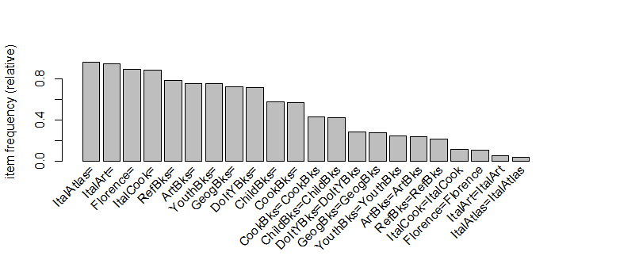

**1. For supp=0.005, conf=0.45, minlen=2, maxlen=4**

> Book_apriori <- apriori(Data1, parameter = list(supp=0.005, conf=0.45, minlen=2, maxlen=4))

Apriori

Parameter specification:

confidence minval smax arem aval originalSupport maxtime support minlen maxlen

0.45 0.1 1 none FALSE TRUE 5 0.005 2 4

target ext

rules FALSE

Algorithmic control:

filter tree heap memopt load sort verbose

0.1 TRUE TRUE FALSE TRUE 2 TRUE

Absolute minimum support count: 10

set item appearances ...[0 item(s)] done [0.00s].

set transactions ...[22 item(s), 2000 transaction(s)] done [0.02s].

sorting and recoding items ... [22 item(s)] done [0.00s].

creating transaction tree ... done [0.00s].

checking subsets of size 1 2 3 4 done [0.01s].

writing ... [12822 rule(s)] done [0.06s].

creating S4 object ... done [0.04s].

> plot(head(sort(Book_apriori),n=20), method="graph", control=list(cex=0.70))

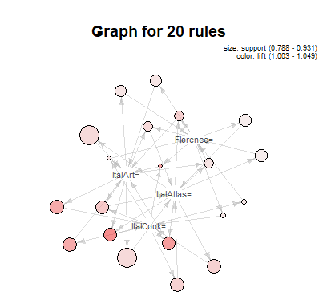

> plot(Book_apriori)

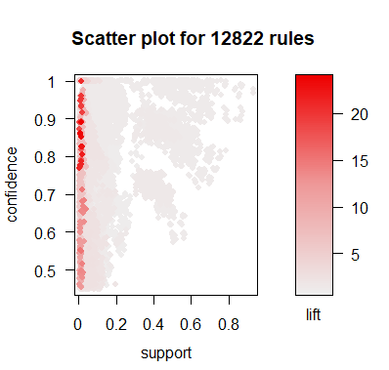

> plot(head(sort(Book_apriori),n=10), method="grouped", control=list(cex=0.2))

